**Employee Task Management**

**Abstract**

In today's fast-paced business environment, effective task management is essential for organizational productivity and success. This paper presents an Employee Task Management System (ETMS) developed using the MERN (MongoDB, Express.js, React.js, Node.js) stack. The system aims to streamline the process of assigning, tracking, and monitoring tasks within an organization.

The ETMS allows administrators to create tasks, assign them to employees, set deadlines, and prioritize tasks based on urgency. Employees can view their assigned tasks, update their progress, and communicate with team members seamlessly through the platform. The system employs role-based authentication to ensure data security and privacy, with administrators having access to all functionalities while employees have limited access based on their roles.

The MERN stack provides a robust and scalable architecture for developing modern web applications. MongoDB serves as the database, storing task-related data in a flexible and scalable manner. Express.js facilitates the development of the backend API, handling requests and responses between the client and the server. React.js, a JavaScript library for building user interfaces, offers a dynamic and responsive frontend for the ETMS, enhancing user experience and interactivity.

Node.js powers the server-side logic, enabling real-time updates and smooth communication between the client and server.

Leveraging MongoDB as the database allows for efficient storage and retrieval of task-related information. Express.js facilitates the development of the backend API, enabling smooth communication between the client and server. React.js provides a dynamic and responsive user interface, enhancing user experience and interaction. Node.js powers the server-side logic, enabling real-time updates and communication between components.

Key features of the ETMS include task creation, assignment, tracking, and communication functionalities. Additionally, the system offers reporting and analytics capabilities, enabling administrators to gain insights into task progress, identify potential bottlenecks, and optimize workflows for increased efficiency.

The ETMS offers a user-friendly interface and robust functionality to meet the diverse task management needs of modern organizations. By leveraging the strengths of the MERN stack, the system ensures scalability, performance, and flexibility, making it suitable for businesses across various industries and sizes.

**CHAPTER 1**

**Introduction**

In today's rapidly evolving business landscape, effective management of employee tasks is essential for organizations to maintain competitiveness and achieve their objectives. With the increasing complexity of projects and the growing importance of collaboration, there is a critical need for robust task management systems that can streamline processes, enhance communication, and optimize productivity. This introduction presents an overview of the significance of employee task management and introduces the Employee Task Management System (ETMS) developed using the MERN (MongoDB, Express.js, React.js, Node.js) stack.

Task management encompasses various activities, including task creation, assignment, tracking, and communication. Efficiently managing these tasks not only ensures timely completion but also facilitates collaboration, resource allocation, and performance evaluation. Traditional methods of task management, such as spreadsheets or email-based systems, often lack the flexibility and scalability required to meet the demands of modern organizations. Hence, there is a growing demand for integrated task management solutions that can centralize information, automate processes, and provide real-time visibility into task status.

The MERN stack, consisting of MongoDB, Express.js, React.js, and Node.js, has emerged as a popular choice for developing modern web applications. MongoDB, a NoSQL database, offers flexibility and scalability, making it suitable for storing diverse types of data, including task-related information. Express.js, a minimalist web framework for Node.js, simplifies the development of backend APIs, enabling seamless communication between the client and server. React.js, a JavaScript library for building user interfaces, provides a dynamic and interactive frontend, enhancing the user experience. Node.js, a runtime environment for executing JavaScript code, powers the server-side logic, facilitating real-time updates and communication.

The Employee Task Management System (ETMS) presented in this paper leverages the capabilities of the MERN stack to provide a comprehensive solution for managing employee tasks. The system allows administrators to create tasks, assign them to employees, set deadlines, and prioritize tasks based on urgency. Employees can access their assigned tasks, update their progress, and communicate with team members through the platform. Role-based authentication ensures data security, with administrators having full access to all functionalities while employees have restricted permissions based on their roles.

Key features of the ETMS include task creation, assignment, tracking, communication, reporting, and analytics functionalities. By centralizing task-related information and providing real-time updates, the system enhances collaboration, improves transparency, and enables informed decision-making. Moreover, the ETMS offers a user-friendly interface, intuitive navigation, and robust functionality, making it suitable for organizations of all sizes and industries.

In summary, effective management of employee tasks is crucial for organizational success in today's dynamic business environment. The Employee Task Management System (ETMS) developed using the MERN stack offers a comprehensive solution for streamlining task management processes

**Module Description**

The Employee Task Management System is a comprehensive software solution designed to streamline task assignment, tracking, and completion within an organization. This module provides a centralized platform where managers can effortlessly assign tasks to individual employees or teams, set priority levels, and establish deadlines for efficient workflow management. Employees, in turn, can easily access their assigned tasks, update their progress, and collaborate with team members as necessary. With features such as file attachment, real-time notifications, and progress tracking, the system facilitates seamless communication and enhances transparency across projects. Security measures, including role-based access control and data encryption, ensure the protection of sensitive information. Additionally, the system is designed for scalability, usability, and easy integration with existing HR systems and project management tools. Through its deployment, organizations can optimize productivity, foster collaboration, and effectively manage their workforce's tasks and projects.

**Key Features:**

**Task Assignment:**

* Managers can create tasks with detailed descriptions, specifying the scope, requirements, and objectives.
* Tasks can be assigned to individual employees based on their skills, availability, and workload.
* Managers can also assign tasks to specific teams, ensuring collaboration among team members for complex projects.

**Priority Setting:**

* Tasks can be categorized into different priority levels such as high, medium, or low.
* Managers can set the priority level for each task based on its importance and urgency.
* Priority levels help employees prioritize their work and focus on tasks that require immediate attention.

**Deadline Management:**

* Each task can have a designated deadline, indicating the date and time by which it needs to be completed.
* Managers can set realistic deadlines considering the task's complexity and the employee's workload.
* Employees receive notifications and reminders as the deadline approaches, helping them stay on track and meet project timelines.

**Progress Tracking:**

* Employees can update the status of their tasks, indicating whether they are in progress, completed, or pending.
* Managers have real-time visibility into the progress of tasks through dashboards or task lists.
* Progress tracking enables managers to identify potential delays or issues and take proactive measures to address them.

**File Attachment:**

* Users can attach relevant files, documents, or resources to tasks for reference or additional context.
* Attachments may include project briefs, specifications, design mockups, or supporting documents.
* File attachments facilitate better understanding of task requirements and ensure all necessary resources are readily available to employees.

**Notifications:**

* The system sends automatic notifications to employees for various events such as task assignments, updates, deadline reminders, or mentions.
* Notifications can be delivered via email, mobile push notifications, or within the application itself.
* Timely notifications keep employees informed and engaged, reducing the likelihood of missed deadlines or overlooked tasks.

**Collaboration:**

* Employees can collaborate on tasks by sharing updates, comments, or feedback within the system.
* Collaboration features may include threaded discussions, mentions, or task-specific chat channels.
* Collaboration fosters teamwork, facilitates knowledge sharing, and improves decision-making processes.

**Reporting:**

* Managers have access to comprehensive reports and analytics to track task completion rates, employee performance, and project metrics.
* Reports may include charts, graphs, or tables summarizing key performance indicators (KPIs) such as task completion time, backlog size, or resource allocation.
* Reporting tools enable managers to gain insights, identify trends, and make data-driven decisions to optimize workflows and resource allocation.

These detailed features collectively empower organizations to efficiently manage their tasks, enhance productivity, and improve communication and collaboration among team members.

**Methodology**

Using the MERN stack (MongoDB, Express.js, React.js, Node.js), can develop a robust and efficient system for employee task management. Here's a methodology for implementing this solution:

**Requirements Gathering:**

Start by understanding the specific requirements of the employee task management system. This includes identifying key features, user roles, and any unique functionalities needed for your organization.

**Database Design:**

Design the MongoDB database schema to store information such as users, tasks, teams, priorities, deadlines, and task statuses. Consider the relationships between different entities and how they will be represented in the database.

**Backend Development (Node.js with Express.js):**

* Set up a Node.js project and use Express.js to create RESTful APIs for handling CRUD (Create, Read, Update, Delete) operations on tasks, users, teams, etc.
* Implement authentication and authorization mechanisms using libraries like Passport.js or JSON Web Tokens (JWT) to ensure secure access to the system.
* Develop business logic to manage task assignments, deadlines, priorities, notifications, and other core functionalities of the system.
* Integrate with the MongoDB database using an ORM (Object-Relational Mapping) library like Mongoose to perform database operations.

**Frontend Development (React.js):**

* Create a React.js project structure and set up necessary dependencies for state management (e.g., Redux or Context API), routing (React Router), and UI components (e.g., Material-UI or Bootstrap).
* Design intuitive user interfaces for different user roles, including managers and employees, to view tasks, assign tasks, update task statuses, and collaborate.
* Implement features such as task lists, task details, task creation forms, notifications, and progress tracking using React components and hooks.
* Use AJAX or Axios to fetch data from the backend APIs and update the UI dynamically based on user interactions.

**Integration and Testing:**

* Integrate the frontend and backend components to ensure seamless communication between the client-side and server-side applications.
* Conduct unit tests, integration tests, and end-to-end tests to verify the functionality, performance, and reliability of the system.
* Perform user acceptance testing (UAT) with stakeholders to gather feedback and make necessary adjustments to meet the requirements.

**Deployment and Monitoring**:

* Deploy the application to a hosting platform such as Heroku, AWS, or Azure, ensuring scalability, reliability, and security.
* Set up monitoring tools (e.g., New Relic, Sentry) to track application performance, detect errors, and troubleshoot issues in real-time.
* Implement logging and error handling mechanisms to capture and analyze runtime errors, exceptions, and user activities.

**Training and Adoption:**

* Provide training sessions and documentation to familiarize users (managers, employees) with the features and functionalities of the employee task management system.
* Encourage user adoption by highlighting the benefits of the system, addressing concerns, and soliciting feedback for continuous improvement.

**Maintenance and Updates:**

* Regularly maintain and update the application to address security vulnerabilities, software bugs, and performance optimizations.
* Incorporate new features, enhancements, and integrations based on evolving business requirements and user feedback.
* Following this methodology will enable you to build an effective employee task management system using the MERN stack, providing a scalable, user-friendly, and efficient solution for your organization's needs.

**CHAPTER 2**

**Literature Survey**

To conduct a thorough literature survey on employee task management systems using the MERN stack, researchers typically begin by defining their objectives and scope. This involves identifying key aspects of task management, such as features, methodologies, and challenges, as well as the specific technologies within the MERN stack - MongoDB, Express.js, React.js, and Node.js - that are relevant to the study. Researchers then compile a list of keywords and search terms related to these topics, including terms like "employee task management," "MERN stack development," and "task tracking software." Using these keywords, researchers search academic databases, such as IEEE Xplore, ACM Digital Library, and Google Scholar, to find relevant studies, articles, and publications. They may also explore conference proceedings, journals, and books in fields like software engineering, project management, and human-computer interaction to gather insights and perspectives on employee task management systems and MERN stack development methodologies. By analyzing and synthesizing existing literature, researchers can gain a comprehensive understanding of the subject, identify gaps in knowledge, and contribute to the advancement of research and practice in this area.

In addition to academic databases, researchers often explore other sources such as industry reports, whitepapers, technical blogs, and online forums to gather a comprehensive understanding of employee task management systems and the MERN stack. Industry reports from market research firms provide insights into trends, adoption rates, and challenges faced by organizations in implementing task management solutions. Whitepapers and technical blogs authored by experts in software development, project management, and technology provide practical guidance, case studies, and best practices for building effective task management systems using the MERN stack. Online forums and communities like Stack Overflow, Reddit, and Quora offer a platform for developers and practitioners to share experiences, seek advice, and discuss issues related to MERN stack development and task management software. By leveraging a diverse range of sources, researchers can gain valuable insights, perspectives, and real-world examples to inform their literature survey and contribute to the body of knowledge in this field.

**CHAPTER 3**

**SYSTEM DESCRIPTION**

### Software Requirements

|  |  |  |
| --- | --- | --- |
| Operating System | : | Windows 10& above |
| Programming | : | MERN stack |
| Simulator tool  **Hardware Requirements** | : | VS 17.7.6 |
| Processor | : | Intel core i3(min) |
| RAM | : | Minimum 4 GB and Recommended 8 GB |
| Hard Disk | : | 24 GB to accommodate the project files, datasets, and software tools |
| Input Device | : | Standard Keyboard and Mouse |
| Output Device | : | Standard Monitor |

**System Tools**

Visual Studio Code is a fast and efficient source code editor available for Windows, Mac OS X, and Linux on your PC. Together with a strong ecosystem of extensions for additional languages and runtimes (such as C++, C#, Java, Python, PHP, Go, and.NET), it comes with built-in support for JavaScript, TypeScript, and Node.js. Using the Electron Framework, Microsoft created the source code editor Visual Studio Code, or VS Code, for Windows, Linux, and macOS. Embedded Git, snippets, intelligent code completion, debugging support, and syntax highlighting are a few of the features.

**Implementation**

Implementing an employee task management system using the MERN stack involves several steps:

**Setting Up the Development Environment:**

* Install necessary software tools such as Node.js, MongoDB, and a code editor (e.g., Visual Studio Code).
* Set up a new Node.js project and initialize it with npm or yarn.

**Backend Development (Node.js with Express.js):**

* Create RESTful API endpoints for tasks, users, teams, authentication, and other functionalities using Express.js.
* Set up MongoDB database connections and define schemas/models for tasks, users, and other entities using Mongoose.
* Implement authentication and authorization mechanisms using libraries like Passport.js or JWT.
* Develop business logic to handle task assignments, deadlines, priorities, notifications, and other core functionalities.

**Frontend Development (React.js):**

* Set up React.js project structure and install necessary dependencies for state management (e.g., Redux or Context API), routing (React Router), and UI components (e.g., Material-UI or Bootstrap).
* Design user interfaces for task lists, task details, task creation forms, notifications, and progress tracking using React components and hooks.
* Implement features such as task assignment, task status updates, file attachments, and collaboration functionalities.
* Integrate with backend APIs using AJAX or Axios to fetch and update data dynamically.

**Integration and Testing**:

* Integrate frontend and backend components to ensure seamless communication between the client-side and server-side applications.
* Conduct unit tests for backend API endpoints using testing frameworks like Jest or Mocha.
* Test frontend components and functionalities using tools like React Testing Library or Enzyme.
* Perform integration tests and end-to-end tests to verify the functionality, performance, and reliability of the system.

**Deployment:**

* Deploy the application to a hosting platform such as Heroku, AWS, or Azure.
* Set up MongoDB Atlas or another cloud-based database service for production data storage.
* Configure environment variables for sensitive information such as database credentials and API keys.
* Ensure scalability, reliability, and security of the deployed application.

**Monitoring and Maintenance:**

* Set up monitoring tools (e.g., New Relic, Sentry) to track application performance, detect errors, and troubleshoot issues in real-time.
* Implement logging and error handling mechanisms to capture and analyze runtime errors, exceptions, and user activities.
* Regularly maintain and update the application to address security vulnerabilities, software bugs, and performance optimizations.
* Incorporate new features, enhancements, and integrations based on evolving business requirements and user feedback.

By following these implementation steps, you can develop a robust and efficient employee task management system using the MERN stack, providing a scalable, user-friendly, and effective solution for your organization's needs.

**CHAPTER 4**

**SYSTEM ANALYSIS**

**Existing system**

Existing employee task management systems typically offer a comprehensive suite of features to facilitate efficient task management within organizations. These systems enable managers to create and assign tasks to employees, specifying details such as deadlines, priorities, and relevant documents. Employees, in turn, can access their assigned tasks, update progress, and collaborate with team members as necessary. Deadline management tools ensure timely completion of tasks, while priority settings help in prioritizing workloads effectively. Collaboration features allow employees to share updates, files, and feedback, fostering teamwork and communication. Moreover, notification systems keep employees informed about task assignments, deadline reminders, and updates, ensuring seamless communication and follow-up. Overall, existing systems are designed to streamline task management processes, enhance productivity, and improve collaboration within teams.

Existing employee task management systems often incorporate additional features such as reporting and analytics functionalities to provide insights into task completion rates, employee performance, and project metrics. These reporting tools enable managers to track key performance indicators (KPIs), identify bottlenecks, and optimize workflows. Furthermore, many systems offer customization options, allowing organizations to tailor the system to their specific needs and workflows. Integrations with other tools and platforms, such as project management software, calendars, and communication tools, enhance the system's functionality and interoperability. Security features, including role-based access control (RBAC), encryption, and compliance with data protection regulations, ensure the protection of sensitive information and maintain data integrity. Continuous updates and support services provided by vendors help in addressing issues, adding new features, and ensuring the system's reliability and scalability. Overall, existing employee task management systems offer a comprehensive solution for organizations to streamline task management processes, enhance collaboration, and improve overall efficiency.

**Disadvantages of Existing system**

While existing employee task management systems offer numerous benefits, they may also have certain disadvantages:

**Complexity**:

Some systems can be overly complex, with a steep learning curve for users. This complexity can lead to resistance from employees and hinder adoption rates within the organization.

**Limited Customization:**

Many systems offer limited customization options, making it challenging for organizations to tailor the system to their unique workflows and requirements. This lack of flexibility can result in inefficiencies and frustrations among users.

**Integration Challenges:**

Integrating existing systems with other tools and platforms, such as project management software or HR systems, may be difficult or require additional development effort. This can lead to data silos and disjointed workflows, reducing overall productivity.

**Cost:**

Implementing and maintaining an employee task management system can be costly, particularly for small and medium-sized businesses with limited budgets. Additionally, some systems may require ongoing licensing fees or subscription costs, further increasing the financial burden.

**Scalability Issues:**

As organizations grow and evolve, existing systems may struggle to scale to meet increasing demands. This can result in performance issues, downtime, and a need for costly upgrades or migrations to more robust solutions.

**Security Concerns:**

Storing sensitive employee and task data within a centralized system poses security risks, including data breaches, unauthorized access, and compliance violations. Ensuring robust security measures is essential but may require additional resources and expertise.

**User Resistance:**

Employees may resist using the system if they perceive it as intrusive or micromanaging. Lack of buy-in from key stakeholders can undermine the system's effectiveness and adoption rates.

**Maintenance Challenges:**

Keeping the system up-to-date with the latest features, security patches, and bug fixes requires ongoing maintenance and support. This can be resource-intensive and may divert attention from other strategic initiatives.

Addressing these disadvantages requires careful consideration during the selection, implementation, and ongoing management of an employee task management system. Organizations should prioritize usability, flexibility, and security while balancing costs and scalability to maximize the system's benefits and minimize drawbacks.

**Proposed System**

The proposed employee task management system is designed to revolutionize how organizations manage their tasks and projects efficiently. It addresses the limitations of existing systems by prioritizing intuitive usability, customization options, and seamless integration with other tools. With a user-friendly interface, employees can easily navigate the system, ensuring widespread adoption and minimal resistance. Customization features allow organizations to tailor the system to their specific workflows and requirements, maximizing productivity and efficiency. Seamless integration with existing tools ensures smooth data flow and eliminates silos, enhancing collaboration and communication across teams. Moreover, the system prioritizes scalability and performance, enabling it to adapt to the organization's evolving needs without compromising on reliability. Robust security measures ensure the protection of sensitive data, maintaining compliance with regulations and safeguarding against potential threats. Advanced reporting and analytics capabilities provide valuable insights into task performance, enabling informed decision-making and continuous improvement. Overall, the proposed system aims to streamline task management processes, drive productivity, and empower organizations to achieve their goals effectively.

**Advantages of Proposed system**

The proposed employee task management system offers several advantages over existing systems:

**Enhanced Usability:**

With an intuitive user interface and streamlined navigation, the proposed system ensures easy adoption and usage by employees at all levels of the organization. This results in increased productivity and reduced training time.

**Customization Options:**

Organizations can tailor the system to their specific workflows, processes, and terminology. This flexibility allows for a more efficient and personalized task management experience, leading to improved team collaboration and task execution.

**Seamless Integration:**

The system seamlessly integrates with other tools and platforms commonly used within the organization, such as project management software, calendars, and communication tools. This integration minimizes data silos, streamlines workflows, and enhances overall efficiency.

**Scalability and Performance:**

Built on scalable architecture, the system can handle increasing volumes of tasks and users as the organization grows. This ensures optimal performance, reliability, and responsiveness, even under heavy workloads.

**Robust Security Measures:**

The system incorporates robust security measures, including encryption, role-based access control (RBAC), and compliance with data protection regulations. This ensures the protection of sensitive employee and task data, minimizing the risk of data breaches and ensuring compliance with regulatory requirements.

**Advanced Reporting and Analytics:**

The system provides advanced reporting and analytics capabilities, offering valuable insights into task performance, employee productivity, and project metrics. This enables informed decision-making, continuous improvement, and strategic planning within the organization.

**Increased Collaboration:**

By facilitating seamless communication, file sharing, and collaboration among team members, the system fosters a culture of collaboration and teamwork. This leads to improved coordination, knowledge sharing, and ultimately, better outcomes for the organization.

**Cost-Effectiveness:**

The proposed system offers a cost-effective solution for task management, reducing the need for multiple disparate tools and platforms. By consolidating task management functionalities into a single integrated system, organizations can achieve cost savings and improve overall operational efficiency.

Overall, the proposed employee task management system offers numerous advantages that empower organizations to streamline task management processes, drive productivity, and achieve their goals effectively.

**Modules developed**

In the proposed employee task management system, the admin module and user login module play crucial roles in managing user access, permissions, and system administration. Here's a breakdown of these modules:

**Admin Module:**

* User Management: The admin module allows administrators to manage user accounts, including creating new accounts, modifying user details, and deactivating or deleting accounts as needed.
* Role-Based Access Control (RBAC): Administrators can define roles with specific permissions and assign these roles to users. RBAC ensures that users have appropriate access levels based on their roles and responsibilities within the organization.
* System Configuration: Admins can configure system settings, such as task categories, priority levels, notification preferences, and integration with external tools or platforms.
* Audit Trails: The admin module may include features for tracking user activities and changes made to the system, providing accountability and transparency.
* Security Management: Admins can manage security settings, including password policies, two-factor authentication, and IP restrictions, to enhance data security and protect against unauthorized access.

**User Login Module:**

* Authentication: The user login module provides a secure authentication process for users to access the system. This may involve username/password authentication, social login (e.g., Google, Microsoft), or single sign-on (SSO) integration with existing authentication systems.
* Authorization: Once authenticated, users are granted access to specific features and functionalities based on their assigned roles and permissions. Authorization ensures that users can only access resources and perform actions allowed by their roles.
* Password Recovery: Users can reset their passwords in case they forget them or need to change them for security reasons. This typically involves a password reset email sent to the user's registered email address.
* Session Management: The module manages user sessions, including session expiration, session timeouts, and session persistence across multiple devices or browser sessions.
* User Profile Management: Users can update their profile information, such as contact details, profile picture, and notification preferences, to personalize their user experience.

Both the admin module and user login module work together to ensure secure access to the employee task management system while providing administrators with the tools they need to manage users, roles, and system settings effectively. These modules are essential components of the overall system architecture, contributing to a seamless and user-friendly experience for both administrators and regular users.

**CHAPTER 5**

**SYSTEM DESIGN**

## Entity Relationship Diagram

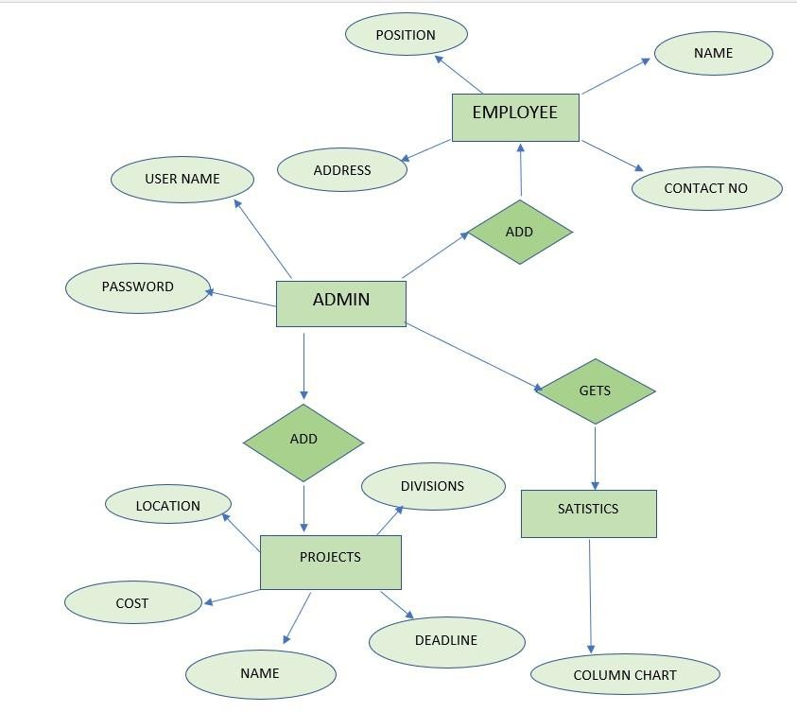

## Data Flow Diagram

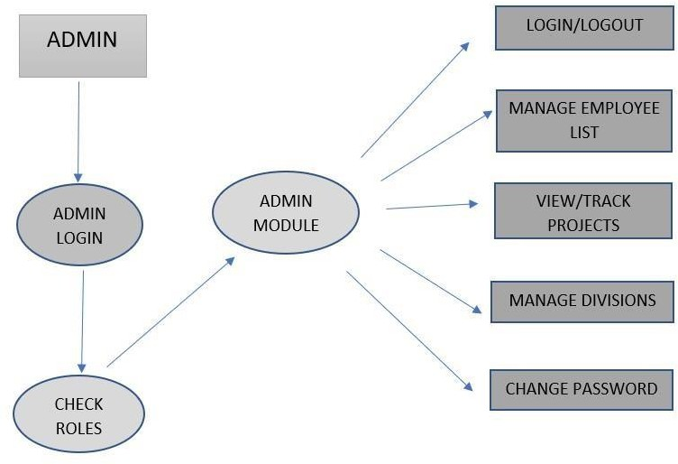

**Use Case Diagram**

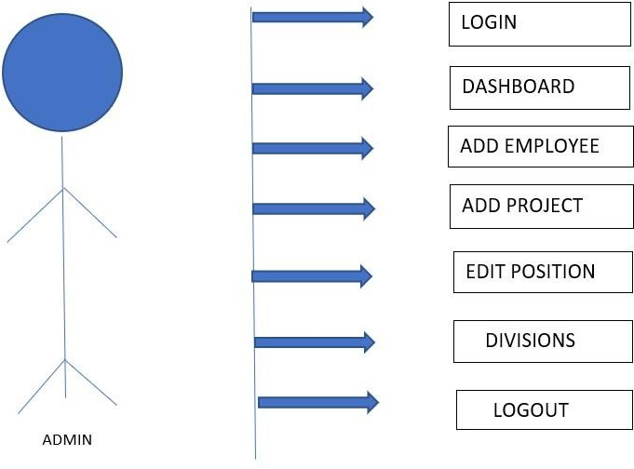

**Output image**

**Screenshot**

**CHAPTER 6**

**Conclusion**

In conclusion, the proposed employee task management system represents a comprehensive solution designed to streamline task management processes, enhance collaboration, and improve overall efficiency within organizations. By prioritizing intuitive usability, customization options, and seamless integration with existing tools, the system aims to address the limitations of existing systems while maximizing productivity and user satisfaction.

The admin module empowers administrators to manage user accounts, define roles and permissions, configure system settings, and ensure data security, while the user login module provides a secure authentication process and personalized user experience for all users. Together, these modules play a crucial role in ensuring secure access, user management, and system administration within the organization.

With features such as role-based access control, advanced reporting and analytics, and robust security measures, the proposed system offers numerous advantages that empower organizations to optimize task management processes, drive collaboration, and achieve their goals effectively. Furthermore, by leveraging scalable architecture and advanced technologies, the system is capable of adapting to the evolving needs of the organization while maintaining optimal performance and reliability.

In summary, the proposed employee task management system represents a significant step forward in enhancing organizational productivity, fostering collaboration, and enabling informed decision-making. By embracing this innovative solution, organizations can unlock new opportunities for growth, efficiency, and success in today's dynamic business environment.

The proposed system's emphasis on user-friendly interfaces and customization options ensures widespread adoption and ease of use among employees, mitigating resistance and maximizing engagement. By empowering administrators with robust tools for user management, role assignment, and system configuration, the system enables organizations to tailor workflows to their unique requirements and scale operations effectively.

Moreover, the integration of advanced reporting and analytics capabilities provides valuable insights into task performance, employee productivity, and project metrics. This data-driven approach facilitates informed decision-making, continuous improvement, and strategic planning, empowering organizations to stay agile and competitive in dynamic business environments.

Ultimately, the proposed employee task management system represents more than just a tool—it embodies a strategic investment in organizational efficiency, collaboration, and success. By embracing this innovative solution, organizations can unlock new levels of productivity, enhance teamwork, and achieve their goals with confidence and precision.

**Future Enhancement**

For future enhancements to the employee task management system, several avenues can be explored to further improve functionality, usability, and effectiveness. Here are some potential areas for enhancement:

**AI-Powered Task Recommendations:**

Integrate artificial intelligence (AI) algorithms to analyze historical task data and user behaviors to provide personalized task recommendations, prioritize tasks, and suggest optimal task assignments based on employee skills and availability.

**Machine Learning for Predictive Analytics:**

Implement machine learning models to predict project timelines, identify potential bottlenecks, and recommend proactive measures to optimize task allocation, resource utilization, and project scheduling.

**Natural Language Processing (NLP) for Task Input:**

Integrate NLP capabilities to allow users to input tasks using natural language, enabling more intuitive task creation and reducing the time and effort required to input task details manually.

**Real-Time Collaboration Features:**

Enhance collaboration capabilities with real-time editing, commenting, and chat functionalities within task details and documents, fostering immediate communication and collaboration among team members.

**Mobile App for On-the-Go Access:**

Develop a mobile application that allows users to access the task management system from their smartphones or tablets, enabling on-the-go task management, updates, and notifications for remote or field-based employees.

**Gamification for Task Completion:**

Implement gamification elements such as badges, rewards, and leaderboards to incentivize task completion, foster healthy competition among employees, and increase engagement with the task management system.

**Integration with Virtual Assistants:**

Integrate with virtual assistant platforms (e.g., Amazon Alexa, Google Assistant) to enable voice-based task management, task reminders, and status updates, providing users with hands-free access to their tasks and schedules.

**Enhanced Data Visualization:**

Improve data visualization capabilities with interactive charts, graphs, and dashboards to provide deeper insights into task performance, team productivity, and project progress, facilitating better decision-making and strategic planning.

**External Integration with Productivity Tools:**

Expand integration capabilities with popular productivity tools such as Microsoft Office 365, Google Workspace, and Slack, allowing seamless data exchange and collaboration across multiple platforms.

**Enhanced Security Features:**

Strengthen security measures with advanced authentication methods (e.g., biometric authentication), data encryption, and compliance with emerging data protection regulations (e.g., GDPR, CCPA) to ensure the privacy and security of sensitive task data.

By continuously enhancing the employee task management system with innovative features and technologies, organizations can stay ahead of evolving business needs, drive productivity, and foster a culture of efficiency and collaboration across the workforce.